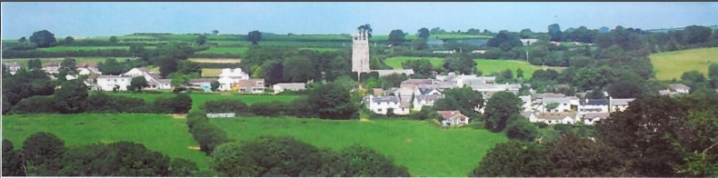
24th November 2025
Dear Councillor,
You are summoned to attend a meeting of North Hill Parish Council on Monday 1st December 2025 at 7.30pm in the Village Hall.
Please find attached the agenda for our meeting. We ask that if any member of the public has issues, they would like to raise that they contact the clerk prior to the meeting so that we can best manage them.
Please remember that the time allotted for Matters of Community Concern is not a forum to discuss what has taken place during this meeting and that any matter raised here would likely be added to the NEXT meeting agenda for discussion.
Yours faithfully,
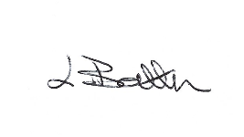
Lena Batten, Clerk to the Council
Members of the public are welcome to attend the meeting. However, we would like those attending to register prior to the meeting by emailing the Parish Clerk. Email: clerk@northhillparish.org.uk
AGENDA
- TO RECEIVE APOLOGIES:
- CODE OF CONDUCT : a) TO RECEIVE DECLARATIONS b) TO GRANT DISPENSATIONS:
3. PUBLIC COMMENTS ON ITEMS ON THE AGENDA ONLY:
4. TO RECEIVE AND APPROVE THE MINUTES OF THE 3rd NOVEMBER 2025 FULL COUNCIL MEETING:
5. ANY MATTERS ARISING FROM PAST MINUTES NOT ON THE CURRENT AGENDA:
6. TO CONSIDER PLANNING APPLICATIONS RECEIVED FROM CORNWALL COUNCIL BY DATE OF THIS MEETING:
6.1 PA25/07912 – To note for information - Land To The South Of Coad's Green And To The West Of The B3257 - Proposal Prior notification of agricultural or forestry development for: The construction of an agricultural general purpose building – withdrawn.
7. ANY APPLICATIONS RECEIVED BEFORE THE DATE OF THIS MEETING: None.
8. TO REVIEW CORRESPONDENCE AND TO AGREED RESPONSES REQUIRED:
8.1 To consider / agree the letter compiled to distribute to all residents of North Hill Village.
8.2 To note for information a letter of thanks has been sent to Elsie Crane for the playing of the cornet on the 9th
November at North Hill Parish Council’s Remembrance Service.
8.3 To receive an update from one Councillor in relation to North Hill Parish’s emergency planning procedures.
8.4 To note for information CIL funds can be donated to support play areas owned by village halls and not the
Parish Council.
8.5 To note for information debris under the bridge at Bathpool was reported on the 9th November 2025.
8.6 To review / resolve to update North Hill Parish Council’s Complaints Procedure.
8.7 To review / agree all meeting dates for 2026 and agree alternative dates for April and May 2026.
8.8 To note for information the estimated costs for waste cleansing services for dog bin emptying at £694.10 plus
VAT for 2026/2027.
8.9 To note for information the LMP grant award for cutting of the footpaths for 2026-27 is estimated at £674.57.
8.10 To consider / resolve whether to request Highways put a 30mph sign at Middlewood as requested by
residents.
8.11 To consider / resolve any response to Cornwall Council’s email “Call for larger sites”.
8.12 To consider / resolve submitting an expression of interest to the CAP for a Community Highways improvement
by the deadline of 27th February 2026.
9. TO REVIEW DETAILS FOR NORTH HILL PARISH COUNCIL CEMETERY: None.
10. APPROVAL OF THE LIST OF PAYMENTS / RECEIPTS FOR NOVEMBER 2025 & TO RECEIVE 30TH NOVEMBER 2025
BANK STATEMENT:
10.1 AUTHORISATION OF EXPENSES INCLUDING SALARY:
i) £18.00 (PAYE G. Pollard payroll November, dd)
ii) £703.12 (Lena Batten, November Salary)
iii) £149.87 (Lena Batten, November NI and tax)
iv) £43.64 (room rent)
v) £17.99 (Lena Batten, Amazon paper)
vi) £30.00 (Western Web, renewal of domain for email)
vii) £43.20 (Western Web, renewal of cloud email account)
viii) £480.00 (Martin Budge, cutting of church yard 2025)
ix) £313.20 (Whitehill, noticeboard for Congdon’s Shop)
x) £1010.00 (Martin Budge, cutting of North Hill Play area)
xi) £128.47 (Kompan Ltd, quarterly play area inspection November 2025).
10.2 RECEIPTS:
None.
10..3 To receive bank statement:
Bank Statement as of 24th November 2025 £21,313.97.
10.4 To consider / resolve grant applications received by the date of this meeting:
i) Coads Green Methodist Church £500.00.
ii) Teylu Theatre Company £500.00.
iii) Coads Green Village Hall £1000.00.
11. TO REVIEW MONTHLY BUDGET RECONCILIATIONS:
11.1 Budget Sheet Attached.
12. TO REVIEW MONTHLY RAG: (Red, Amber, Green)
12.1 RAG Sheet attached.
13. REPORT FROM CORNWALL COUNCIL WARD MEMBER COUNCILLOR PARSONS:
14. ITEMS FOR INCLUSION AT THE NEXT MEETING:
15. DATE & TIME OF NEXT MEETING:
16. CLOSE OF BUSINESS:

